Congnizant 2

1.Wt are project ur done?

Recent project will be

Job spring boot application

<https://www.youtube.com/watch?v=6fcoYGqvg6o>

It is mortgage APPLICATION

Tach stack react js

Backend is spring boot

From devops concept im in to AWS and azure actually

Ok particular based upon ok n request

Wrk exp AWS service and eks and ecs

Externally use mango db and elastic cloud &log collection

Over all hosted in 3 diff environment

Dev

Uat

Production

Im responsible for both infrastructure pipeline and application pipeline

2.Q.it is entirely hosted on cloud or om premises also there?

This particular project completedly aws

Hava u work on any project experience in k8s and container?

Im worked on exp with docker and kubernetes and on premises like Rancher apart from that eks and also exp  experience familer experience

3.U wrk done azure as well?

Yes

4.Can u please explain the architecture of k8s?

<https://www.geeksforgeeks.org/kubernetes-architecture/>

It is self hosted k8s

Control plane

Control plane communication with the API server

Here we have multiple master based on requirements worked on,.

Go for managed k8s aks or eks

We don't have access bility vendor itself

That why managed k8s very popular

And

5.Can you please explain k8s components?

<https://kubernetes.io/docs/concepts/overview/components/>

We can start with api server

Single point of contact admi prospective and

Schedule

Endpoints

Replication controller

Node controller

Etcd

Let off add-ons

Kubeproxy

Kubelet it is service it is not a container

6.Q:suppose I have deployment,so we need upgrade deployment in k8s?

Wt are process u following?

<https://kubernetes.io/docs/tutorials/kubernetes-basics/update/update-intro/>

It is non prd

It is directed upgrade the manifest file

And perform the rolling out deployment

---+;

In production case we follow the blue green deployment for that load balancer and service mesh

---+

7.Wt is blue green deployment

<https://semaphoreci.com/blog/blue-green-deployment>

<https://nodramadevops.com/2019/04/origin-story-the-blue-green-deployment-method/>

Now blue consider as live environment

It is provided the tracking for the application

Green it is new version of the application

We can do diff ways

One is switch traffic and roll out the new environment

Risknit may be cause downtime application

It can be over come that we can use canary based deployment

That mean we all the partially amount traffic to green and other traffic in old env

8.Wt is default strategy deployment in k8s?

In space upgrade and rolling update

Rolling Deployment. A rolling deployment is the default deployment strategy in Kubernetes. It replaces the existing version of pods with a new version, updating pods slowly one by one, without cluster downtime.

9.Wt is difference between replica set vs deployment set

<https://www.kubermatic.com/blog/keeping-the-state-of-apps-6-introduction-to-statefulsets/>

<http://wiki.ciscolinux.co.uk/index.php/Kubernetes/Deployment,_ReplicaSet_and_Pod>

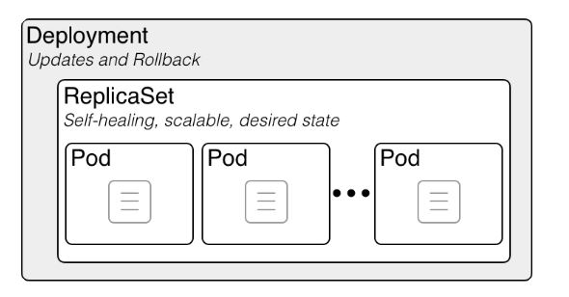

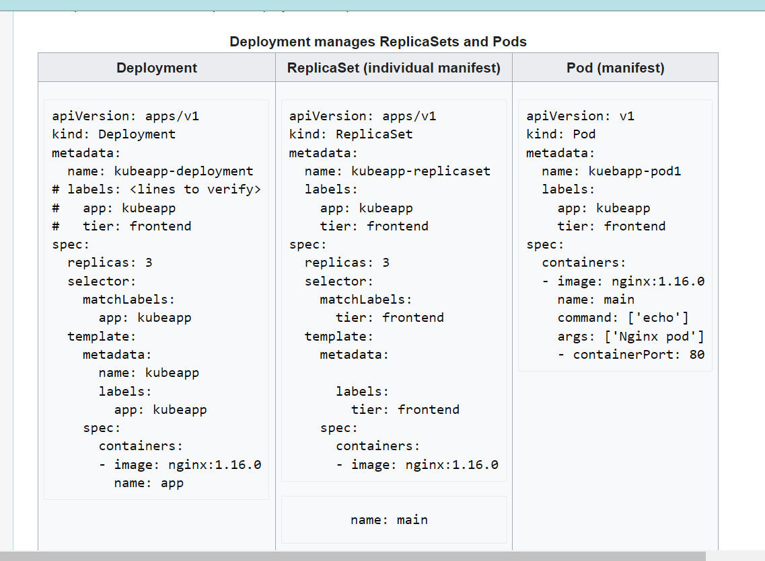

Main tain number of pod for replica set

If u make changes images in manifest file, here not automatically deploy in replica set,

That means manuvally delete the pods,

Then only all pods deploy same time

Here deployment over time we can automatically,we are not manuvally delete the pods

Delay issues we reduce

10.Wt is statefullset kubernetes ?

<https://www.kubermatic.com/blog/keeping-the-state-of-apps-6-introduction-to-statefulsets/>

<https://kubernetes.io/docs/concepts/workloads/controllers/statefulset/>

Why use headless service in StatefulSet?

Advantages of Headless Services  
  
Easy Pod discovery in the StatefulSet. Pods can be addressed more generally by using their DNS names. Utilizes each pod's sticky identity in a stateful service (i.e. you can address a specific pod by name). Write operations are synchronized.

Mangodb,postgres, MySQL,

Primary and secondary multible

Container host name will not change after upgrade

It will have name resolution

Pod restarted attach volume actually

11.Have wrk experience pv in k8s?

Yes

<https://kubernetes.io/docs/concepts/storage/persistent-volumes/>

<https://blog.mayadata.io/understanding-persistent-volumes-and-pvcs-in-kubernetes>

12.Wt is default base use case volume attached to pods?

<https://www.alibabacloud.com/blog/kubernetes-volume-basics-emptydir-and-persistentvolume_594834>

Here manuvally create pv in aws end

If u have storage class it is dynamic provisioning

If u want more control , manuvally create volume and then attach it

13.If I have 2 pod in our cluster,I want send traffic pod a routed to pod b only?not other ways,how can achieve

There is routing policy

To restrict the traffic b/w the pods

What are the 2 types of network policies in Kubernetes?

policyTypes: Specifies the type of policy rules: Ingress, Egress or both. ingress: Defines the ingress policy rules for the target pods. egress: Defines the egress policy rules for the target pods.

What is the difference between firewall and network policy in Kubernetes?

A NetworkPolicy controls traffic within the cluster (known as east-west traffic) while a firewall restricts ingress and egress traffic to or from the cluster (known as north-west traffic). What Ports and Protocols Should Be Allowed by a Kubernetes Firewall

14.Q.When we are create service so it automatically identify the pods right, how does identify?

Not only deployment and service

Everything happened the label

<https://docs.aws.amazon.com/eks/latest/userguide/sample-deployment.html>

15.Did you wrk on ingress in kubernetes ?

## What is Ingress?

[Ingress](https://kubernetes.io/docs/reference/generated/kubernetes-api/v1.29/#ingress-v1-networking-k8s-io) exposes HTTP and HTTPS routes from outside the cluster to [services](https://kubernetes.io/docs/concepts/services-networking/service/) within the cluster. Traffic routing is controlled by rules defined on the Ingress resource.

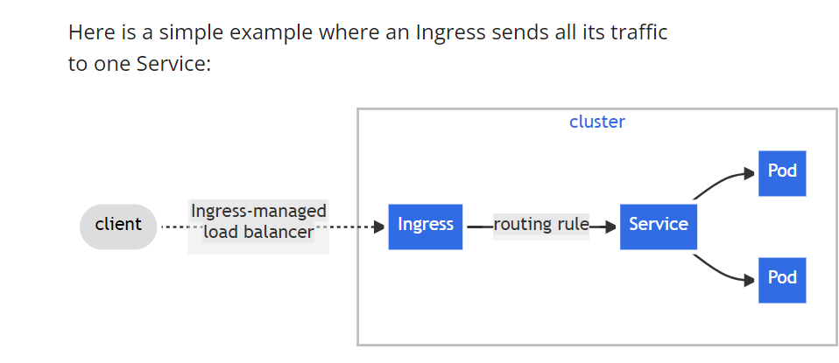

Ngixn and load balancer actually

16.How did you configure ingress ngnix controller?

<https://docs.nginx.com/nginx-ingress-controller/configuration/ingress-resources/basic-configuration/#:~:text=The%20Ingress%20Controller%20generates%20NGINX,and%20the%20Ingress%20Controller's%20ConfigMap>.

It is stright forward ngixn

We can directly name deploy like yaml file.and nessary service and one thing we use SSL certificate with ingress resources ,

We Will be basically route the traffic,

Which is like l7 layer

17.Q:I have multiple cluster env, my wrk station want communication with all of them,how can achieve?

Kubernetes configuration fileKubernetes uses a YAML file called kubeconfig to store cluster authentication information for kubectl . kubeconfig contains a list of contexts to which kubectl refers when running commands. By default, the file is saved at $HOME/. kube/config . A context is a group of access parameters.

<https://www.redhat.com/sysadmin/kubeconfig>

In our kube config file so can merge,I used tool called kube Ms and kubectl

To change context

18.R u wrk exp helm in k8s?

What does Helm command do?

How Helm works. The Helm application library uses charts to define, create, install, and upgrade Kubernetes applications. Helm charts allow you to manage Kubernetes manifests without using the Kubernetes command-line interface (CLI) or remembering complicated Kubernetes commands to control the clust

What is Helm used for?

Helm helps you manage Kubernetes applications — Helm Charts help you define, install, and upgrade even the most complex Kubernetes application. Charts are easy to create, version, share, and publish — so start using Helm and stop the copy-and-paste

<https://dev.to/aws-builders/k8s-quickstart-helm-566o>

No I don't create very complex structure

When u create helm chart what r default folder u can see?

Charr.yam

Template folder

Deployment yaml

Service yaml

Value.files

19.I want particular pod it will be created,on specific node,how can do that

We can use 3 diff ways

Simple way is node selector

Little complex special node

Only one pod to only node then toleration we have good choice

<https://kubernetes.io/docs/concepts/scheduling-eviction/assign-pod-node/>

* nodeSelector — This is a simple Pod scheduling feature that allows scheduling a Pod onto a node whose labels match the nodeSelector labels specified by the user.
* Node Affinity — This is the enhanced version of the nodeSelector introduced in Kubernetes 1.4 in beta. It offers a more expressive syntax for fine-grained control of how Pods are scheduled to specific nodes.
* Inter-Pod Affinity — This feature addresses the third scenario above. Inter-Pod affinity allows co-location by scheduling Pods onto nodes that already have specific Pods running.

<https://medium.com/kubernetes-tutorials/learn-how-to-assign-pods-to-nodes-in-kubernetes-using-nodeselector-and-affinity-features-e62c437f3cf8>

20.If container restart running,how to trouble shooting?

Understanding Pod Restarting IssuesThere are several reasons why a pod might restart: Crash Loop Back-Off: If an application within a pod fails repeatedly, Kubernetes enters a “CrashLoopBackOff” state, which indicates that the pod is constantly restarting due to a persistent failure.

<https://lumigo.io/kubernetes-troubleshooting/kubectl-restart-pod/>

he Always restart policy is the default policy in Kubernetes. So if we create a Pod without setting the restartPolicy field, then Kubernetes will automatically set it to Always. By using this policy, containers will restart when they terminate, regardless of their exit statu

<https://www.baeldung.com/linux/kubernetes-always-vs-onfailure-restart-policy#:~:text=The%20Always%20restart%20policy%20is,regardless%20of%20their%20exit%20status> The liveness probe ensures that an application within a container is live and operational based on a specified test. The kubelet uses liveness probes to know when to restart a container. Applications that error or transition to broken states will be picked up and can be fixed in many instances by being restarted..

We need check status of the pods

Kubectl get pods

Get the logs

Check the database issue

There are many reasons pod can restart

Pod restarted Due to configure reading ness probe and live probe